Day27&28 - Task12 - AWS S3 Bucket

1.Create an S3 bucket and upload some objects to S3.
To create an Amazon S3 bucket and upload files (objects) to the bucket using the AWS Management Console.
Step 1: Sign in to AWS Management Console
- Open a web browser.
- Navigate to the AWS Management Console.
- Sign in using your AWS account or IAM user credentials.

Step 2: Open the Amazon S3 Service
- In the AWS Console search bar, type S3.
- Click S3 from the list of AWS services.
- The Amazon S3 dashboard will open.
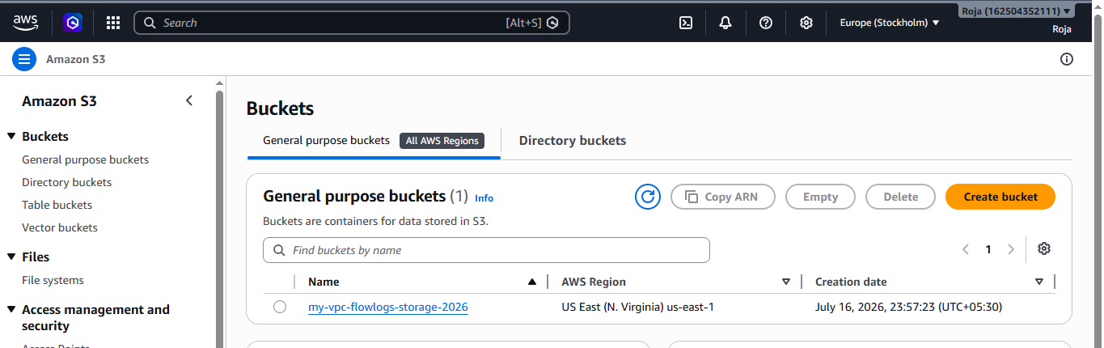

Step 3: Create an S3 Bucket
- Click Create bucket.
- Enter a globally unique bucket name.
  - Example: rams-bucket-1542
- Select the AWS Region.
  - Example: Europe (Stockholm) eu-north-1
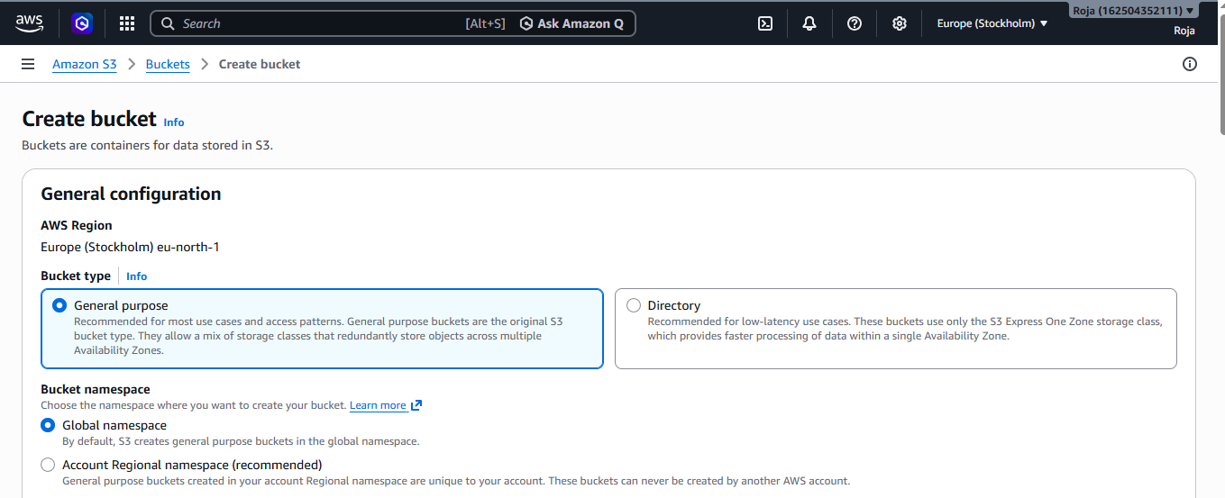
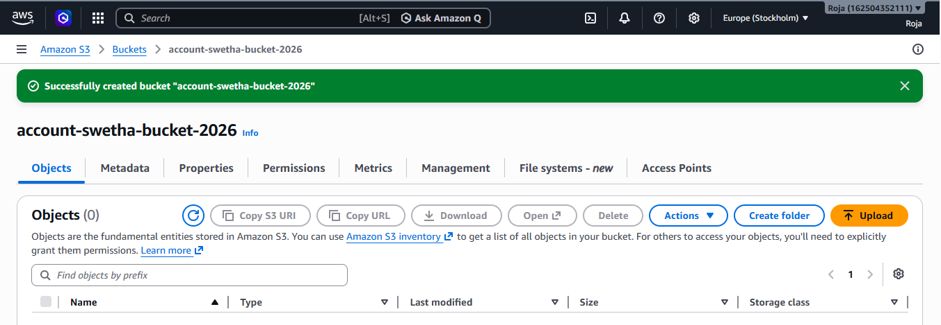

Step 4: Open the Bucket
- Click the name of the newly created bucket.
- The bucket will open to the Objects tab.
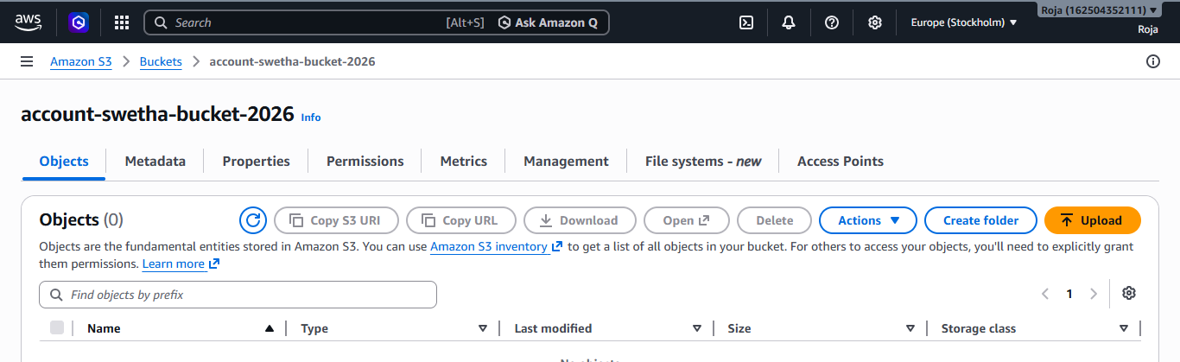

Step 5: Upload Objects to the Bucket
- Click Upload.
- Click Add file.
- Browse your local computer and select one or more files.
- Click Open.
- Verify the selected files appear in the upload list.
- Leave the default upload options unchanged.
- Click Upload.
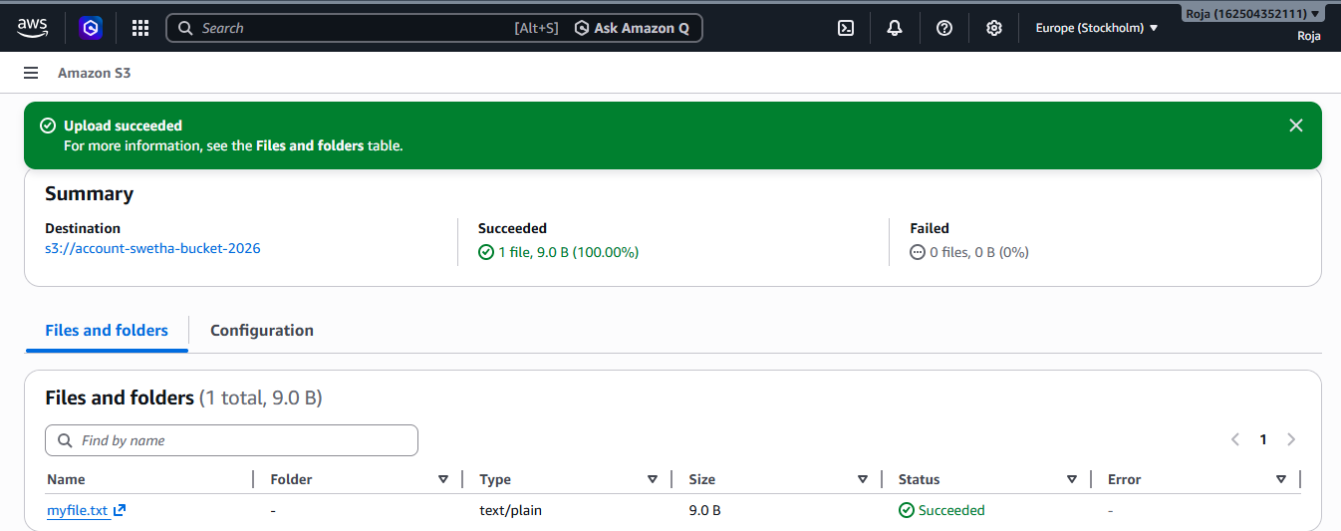
Step 6: Verify Uploaded Objects
- Return to the Objects tab.
- Confirm that all uploaded files are listed.
- Verify details such as:
  - Object name
  - Size
  - Last modified date
  - Storage class (Standard)
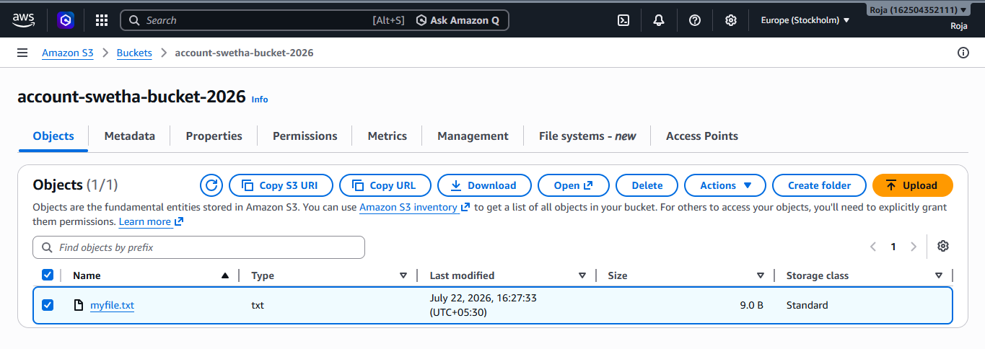
Step 7: Download an Object (Verification)
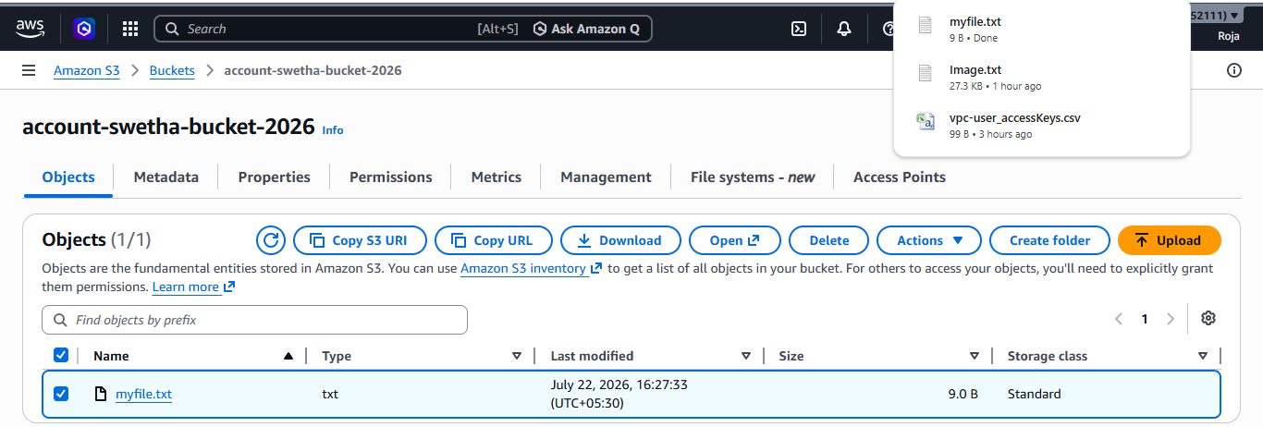

2. Deploy a static website in the S3 bucket.

To host and deploy a static website using an Amazon S3 bucket.

Step 1: Open the Amazon S3 Service
- In the AWS Console search bar, type S3.
- Click S3 from the list of AWS services.
- The Amazon S3 dashboard will open.

Step 2: Create an S3 Bucket
- Click Create bucket.
- Enter a globally unique bucket name.
  - Example: account-static-bucket-2026
- Under Object Ownership, leave ACLs disabled (recommended).
- Under Block Public Access settings, uncheck Block all public access.
- Read the warning and acknowledge it by selecting the confirmation checkbox.
- Leave the remaining settings as default.
- Click Create bucket.
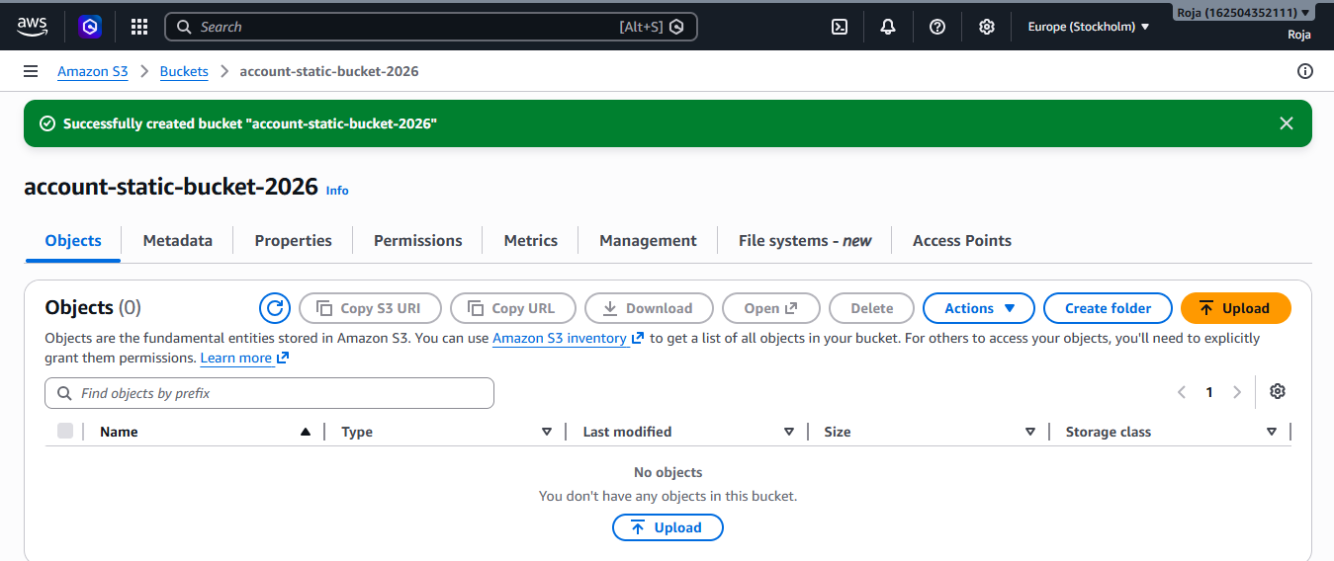

Step 3: Upload Website Files
- Open the newly created bucket.
- Select the Objects tab.
- Click Upload.
- Click Add files.
- Select the website files:
  - index.html
  - error.html
  - CSS, JavaScript, images (if any)
- Click Upload.
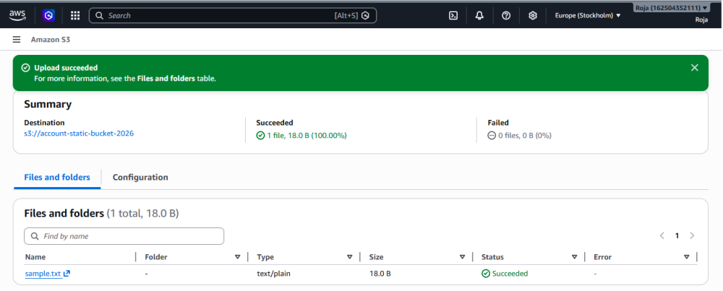

Step 4: Enable Static Website Hosting
- Open the bucket.
- Select the Properties tab.
- Scroll down to Static website hosting.
- Click Edit.
- Choose Enable.
- Select Host a static website.
- Enter:
  - Index document: index.html
  - Error document: error.html
- Click Save changes.
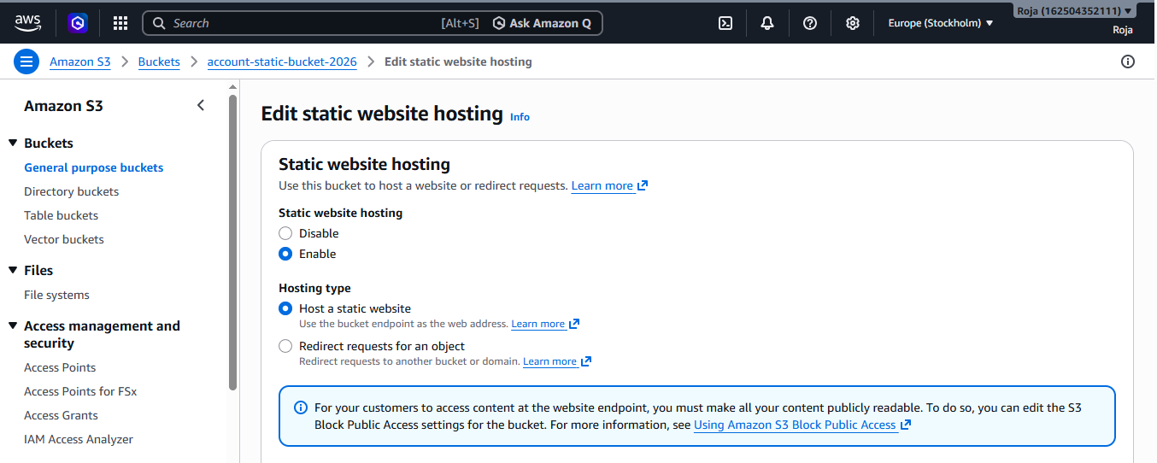
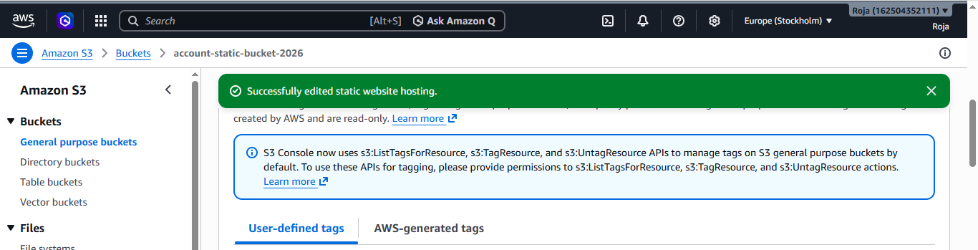

Step 5: Grant Public Read Access
- Open the bucket.
- Select the Permissions tab.
- Scroll to Bucket Policy.
- Click Edit.
- Paste the bucket policy
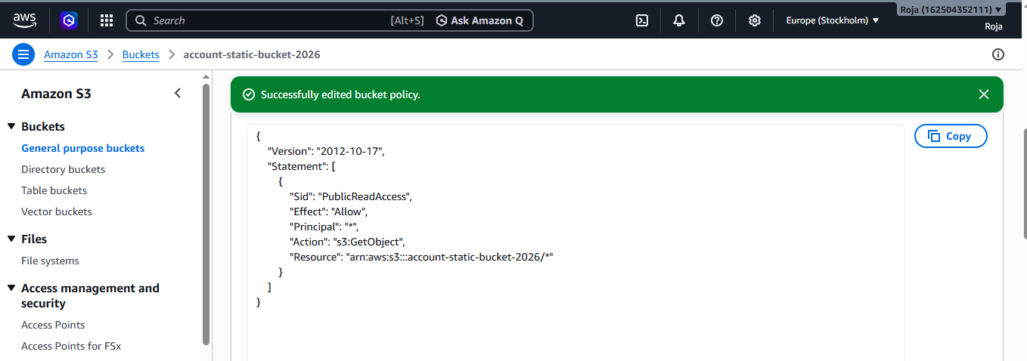
Step 6: Verify Object Permissions
- Open the Objects tab.
- Ensure the uploaded files are present.
- Verify they are accessible through the bucket policy.
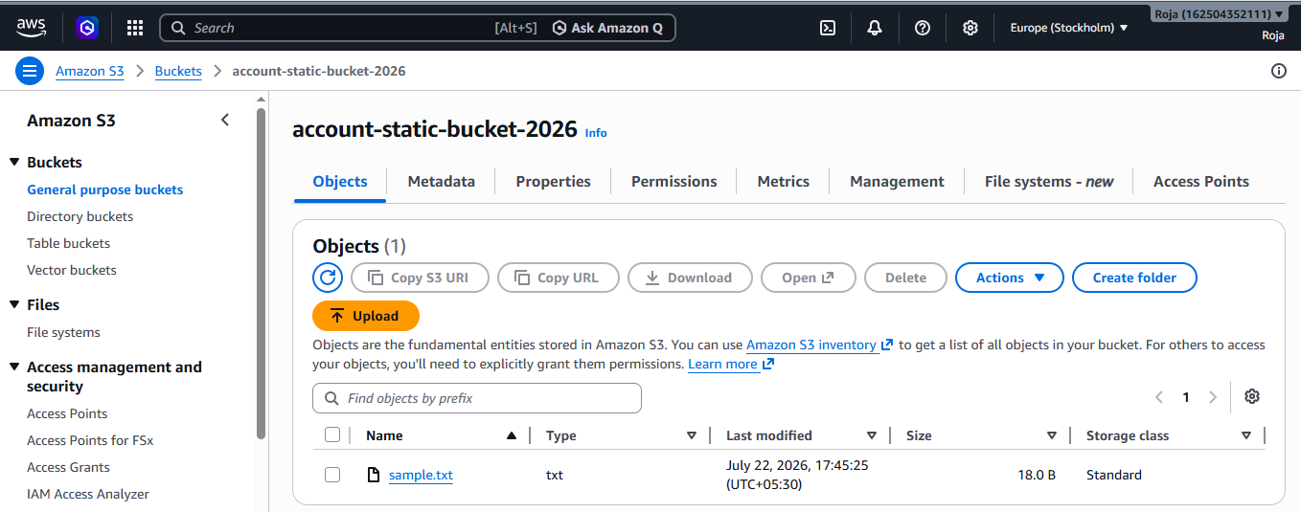

Step 7: Access the Static Website
- Go to the Properties tab.
- Scroll to Static website hosting.
- Copy the Bucket website endpoint URL.
- Open the URL in a web browser.
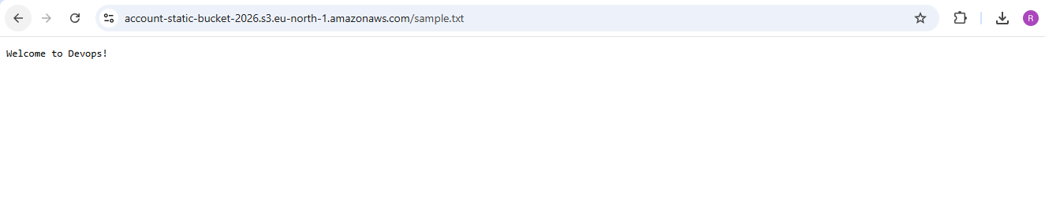
3. Enable cross-region replication on S3 buckets.
To configure Cross-Region Replication (CRR) between two Amazon S3 buckets located in different AWS Regions.
Step 1: Create the Source Bucket
- Open the Amazon S3 service.
- Click Create bucket.
- Enter a globally unique bucket name.
  - Example: aacount-static-bucket-2026
- Select the AWS Region : eu-north-1
- Leave the remaining settings as default.
- Click Create bucket.
Step 2: Create the Destination Bucket
- Click Create bucket again.
- Select a different AWS Region.
Example: us-east-1
- Enter another globally unique bucket name.
Example: student-destination-bucket-2026
- Leave the remaining settings as default.
- Click Create bucket.
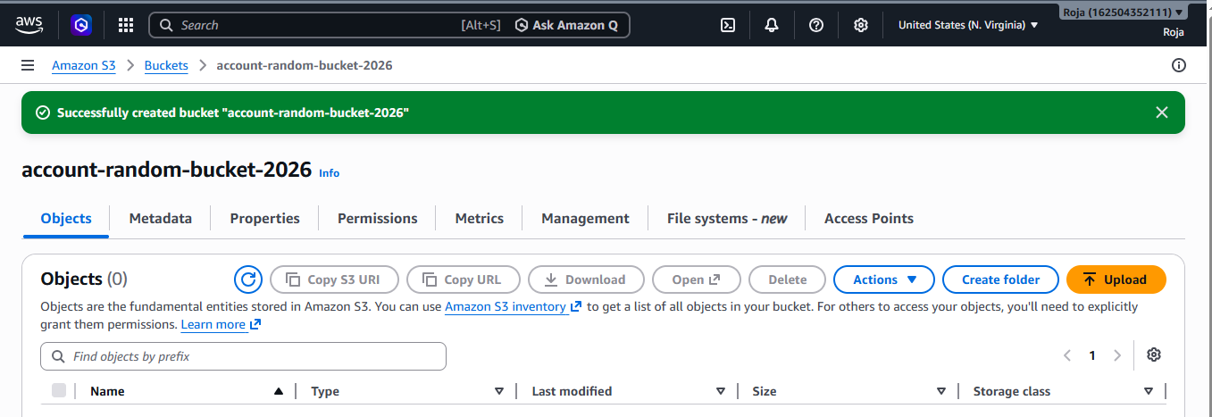

Step 3: Enable Versioning on the Source Bucket
- Open the source bucket.
- Go to the Properties tab.
- Scroll to Bucket Versioning.
- Click Edit.
- Select Enable.
- Click Save changes.
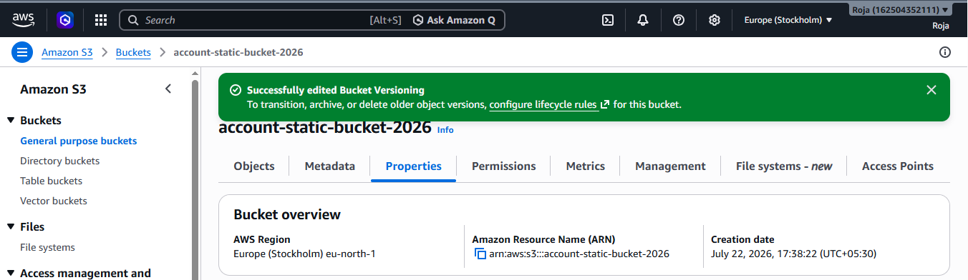

Step 4: Enable Versioning on the Destination Bucket
- Open the destination bucket.
- Go to the Properties tab.
- Scroll to Bucket Versioning.
- Click Edit.
- Select Enable.
- Click Save changes.
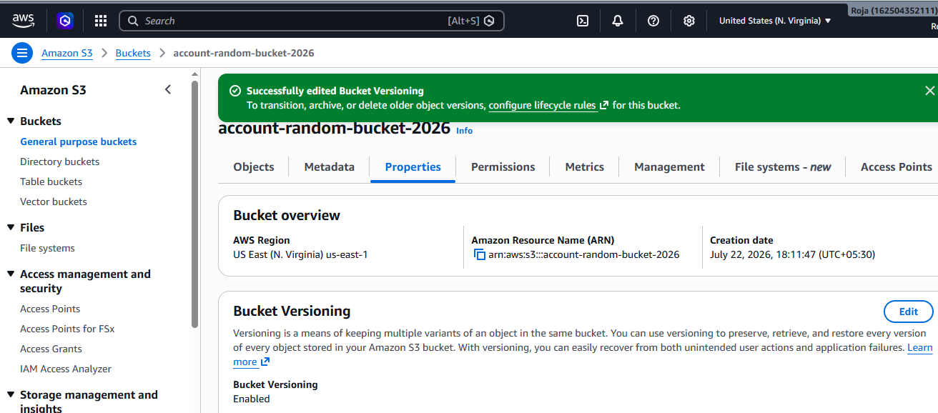

Step 5: Configure Cross-Region Replication
- Open the source bucket.
- Go to the Management tab.
- Scroll to Replication rules.
- Click Create replication rule.
- Enter a rule name.
  - Example: CRR-Rule
- Select Apply to all objects in the bucket.
- Under Destination, choose:
- Specify a bucket in this account
- Select the destination bucket.
- Choose Change object ownership to destination bucket owner (if required).
- Under IAM Role, select:
- Create new role (recommended)
- Leave the remaining options as default.
- Click Save.
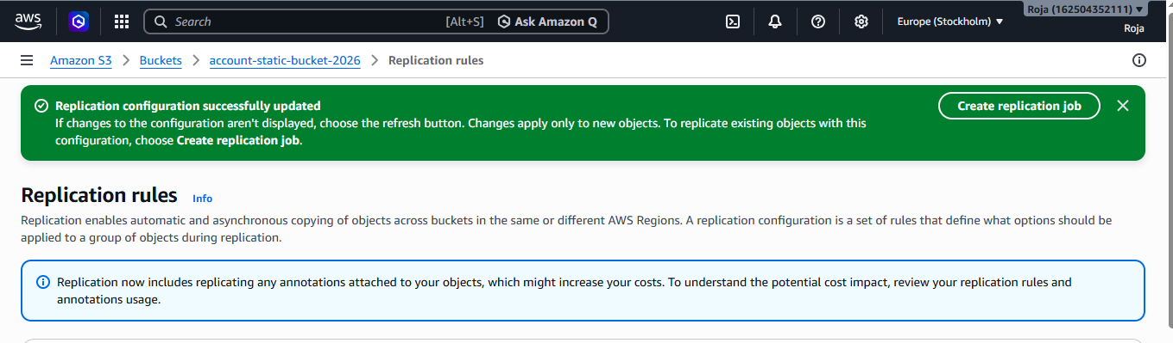

Step 6: Upload an Object to the Source Bucket
- Open the source bucket.
- Go to the Objects tab.
- Click Upload.
- Select a file from your local computer.
- Example: doc.txt
- Click Upload.
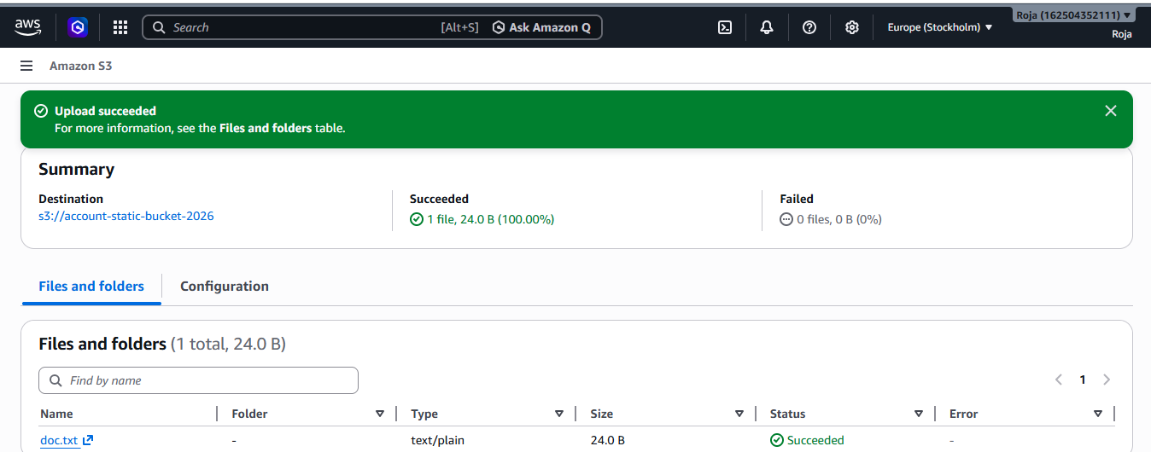

Step 7: Verify Replication
- Wait for a few moments.
- Open the destination bucket.
- Select the Objects tab.
- Verify that the uploaded object appears in the destination bucket.
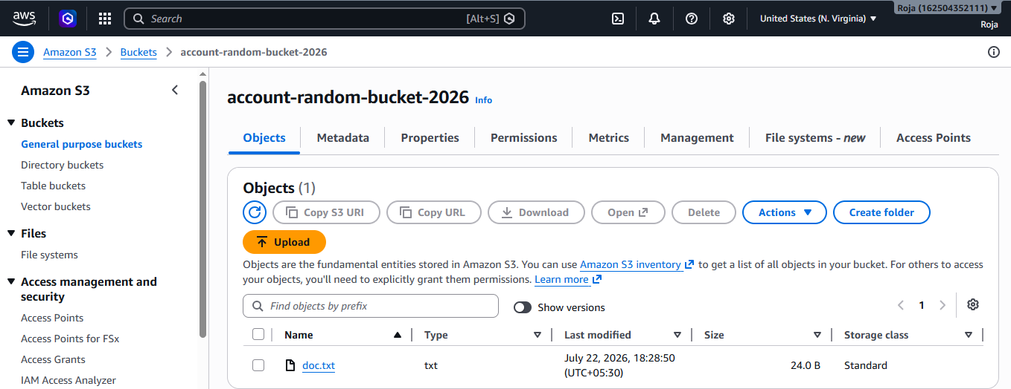
4. Configure a bucket policy so only the Admin user can see the objects of the S3 bucket.

To configure an Amazon S3 bucket policy that allows only the Admin IAM user to view the objects stored in an S3 bucket.
Step 1: Open the Amazon S3 Service
- Create an s3 bucket
- Upload objects to the bucket

Step 2: Obtain the Admin User ARN
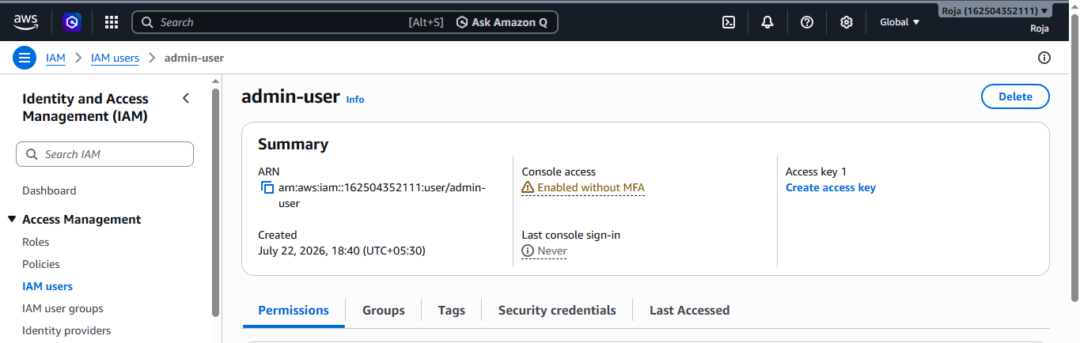

Step 3: Configure the Bucket Policy
- Return to the Amazon S3 service.
- Open the required bucket.
- Select the Permissions tab.
- Scroll down to Bucket Policy.
- Click Edit.
- Replace the placeholders (YOUR-BUCKET-NAME and YOUR-ACCOUNT-ID) with your actual bucket name and AWS account ID, then paste the following policy:
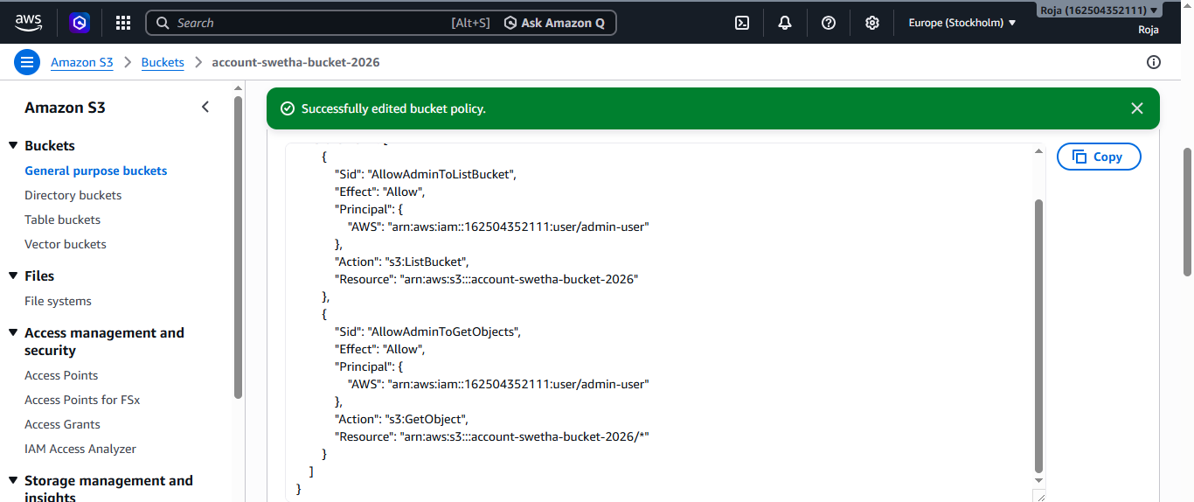
Step 4: Verify Access Using the Admin User
- Sign out of the current AWS account.
- Sign in using the Admin IAM user.
- Open the Amazon S3 service.
- Open the configured bucket.
- Verify that the uploaded objects are visible and can be downloaded.
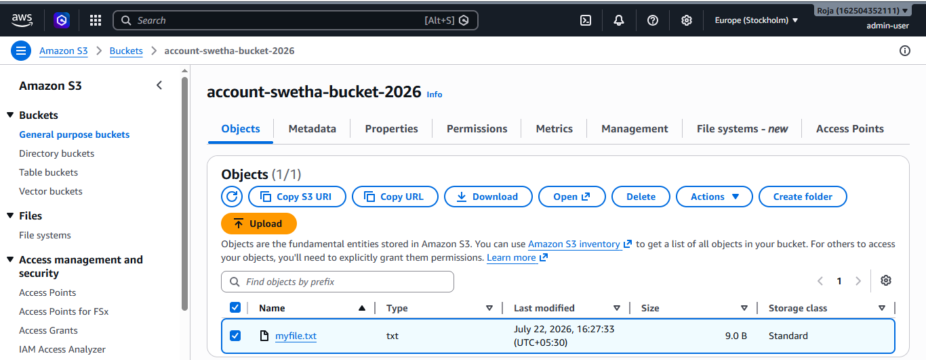

5. Set up lifecycle policies to automatically transition or delete objects based on specific criteria.
To configure an Amazon S3 Lifecycle policy that automatically transitions objects to a different storage class or deletes them after a specified period.
Step 1: Open the Amazon S3 Service
- In the AWS Console search bar, type S3.
- Click Amazon S3 from the list of services.
- The Amazon S3 dashboard will open.
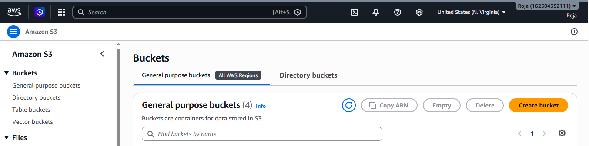

Step 2: Create an S3 Bucket
- Upload Objects to the Bucket
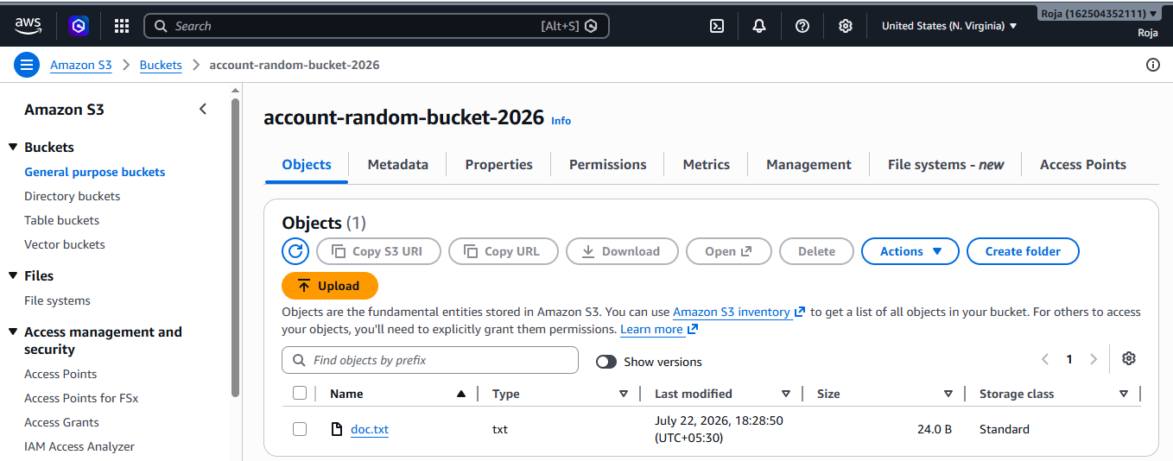

Step 3: Open the Lifecycle Rules Section
- Open the S3 bucket.
- Select the Management tab.
- Scroll to Lifecycle rules.
- Click Create lifecycle rule.

Step 4: Configure the Lifecycle Rule
- Enter a rule name.
  - Example: Lifecycle-Policy
- Under Choose a rule scope, select:
  - Apply to all objects in the bucket
- Acknowledge the warning if prompted.
- Click Next or continue to the lifecycle actions section.

Step 5: Configure Transition Action
- Under Lifecycle rule actions, select:
  - Transition current versions of objects between storage classes
- Choose the destination storage class.
  - Example: S3 Standard-IA
- Specify the transition time.
  - Example: 30 days after object creation

Step 6: Configure Expiration (Delete Objects)
- Select:
  - Expire current versions of objects
- Enter the expiration period.
  - Example: 90 days after object creation
- Review and create rule.
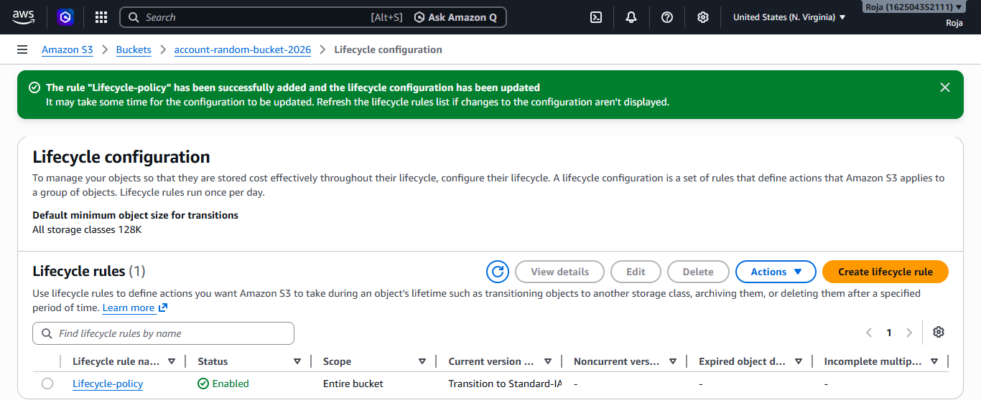

Step 7: Verify the Lifecycle Rule
- Open the Management tab of the bucket.
- Confirm that the newly created lifecycle rule is listed.
- Review the rule details to ensure the transition and expiration settings are correct.
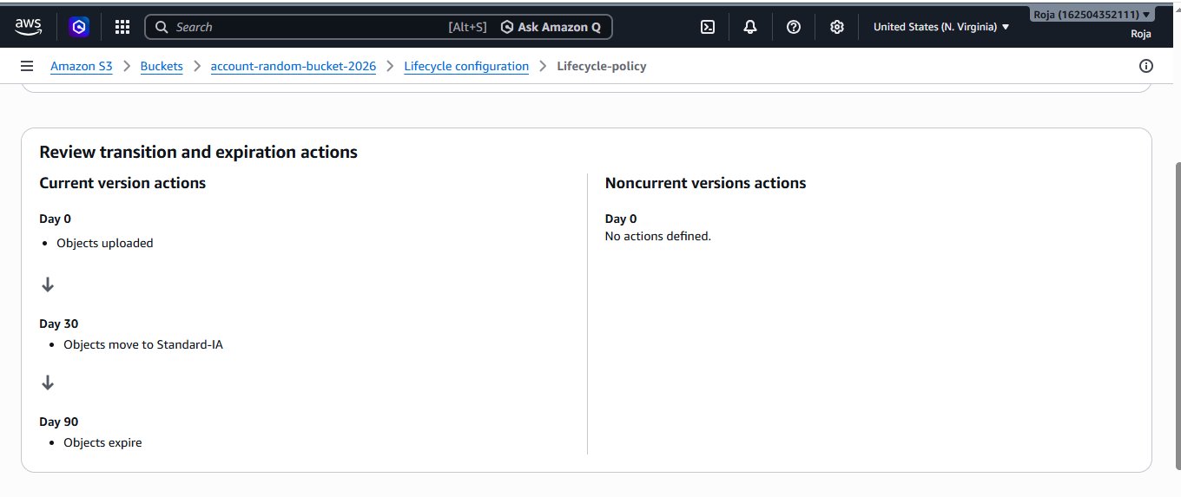

6. Push some objects to S3 using the AWS CLI.

To upload files (objects) from a local system to an Amazon S3 bucket using the AWS Command Line Interface (AWS CLI).
Step 1: Verify AWS CLI Installation
- Open the terminal or command prompt.
- Check the installed AWS CLI version by running: aws –version and Configure AWS CLI
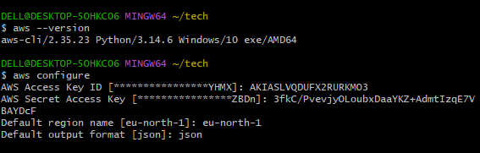

Step 2: Verify the S3 Bucket and Create Sample Files
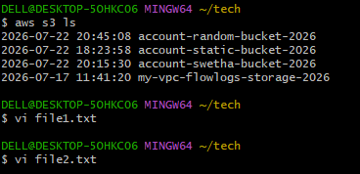

Step 3: Upload a Single File to the S3 Bucket, Verify Uploaded Objects and Download an Object
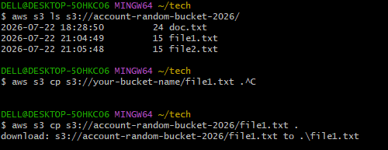
7. Write a Bash script to create an S3 bucket.

To write and execute a Bash script that creates an Amazon S3 bucket using the AWS Command Line Interface (AWS CLI).
Step 1: Verify AWS CLI Installation and Configure AWS CLI
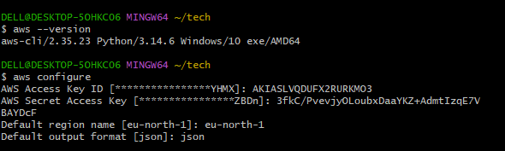

Step 2: Create a Bash Script and content to the script
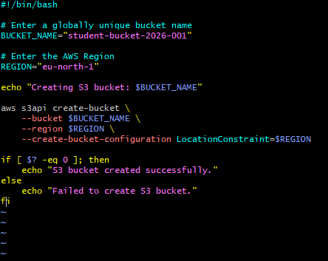

Step 3: Provide Execute Permission, execute the Bash Script and Verify the Bucket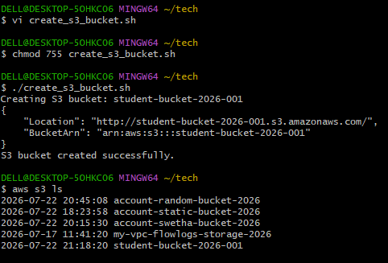
Step 4: Verify in AWS Management Console
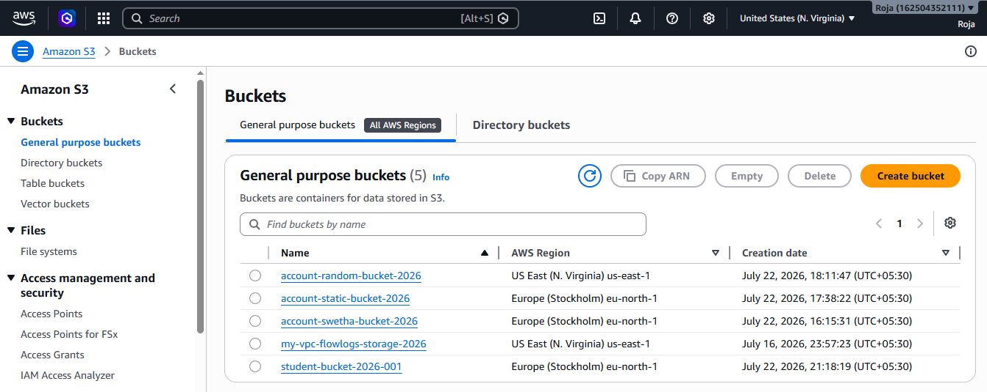

8. Upload a 1 GB file to S3 using the CLI.

To create a 1 GB file on the local system and upload it to an Amazon S3 bucket using the AWS Command Line Interface (AWS CLI).
Step 1: Verify AWS CLI Installation and Configure AWS CLI
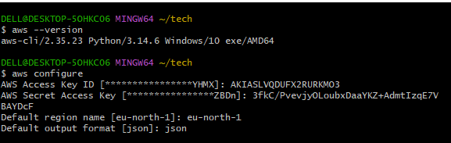

Step 2 : Verify the S3 Bucket
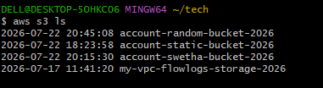

Step 3: Create a 1 GB File for Linux/Ubuntu/macOS
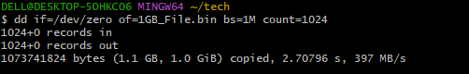

Step 4: Verify the File Size and Upload the File to Amazon S3
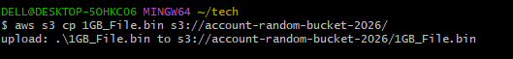

Step 5: Verify the Uploaded Object
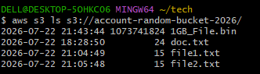

Step 6: Verify in AWS Management Console
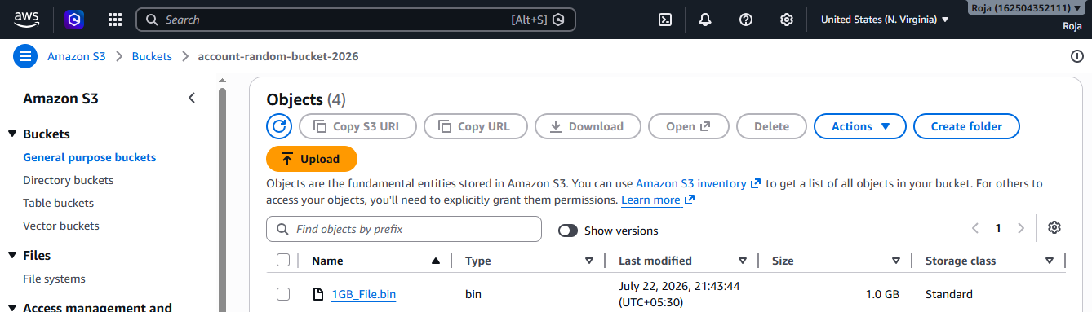

Step 7: Download the File
